EMPLOYEE ATTRITION PREDICATION
Using IBM SPSS Modular
A
PROJECT REPORT
SUBMTTED BY
PRIYANSHI
ROLLNO: 25050020013
in partial fulfilment of Summer Internship for the award of the degree
Of
MASTER OF BUSINESS ADMINISTRATION
IN

SESSION 2026-2027
UNDER THE GUIDANCE OF
MR. Ferhan Ahmed
IBM Trainer
Rawatpur, Prayagraj,
Uttar Pradesh 211012

ACKNOWLEDGEMENT

I would like to express my sincere gratitude to Mr. Ferhan Ahmed (IBM Trainer) for his valuable guidance, support, and encouragement throughout the completion of my project titled “Employee Attrition Prediction Using IBM SPSS Modeler.” His guidance helped me develop a better understanding of IBM SPSS Modeler and its application in employee attrition prediction.

I would also like to express my heartfelt thanks to the faculty members of United University for their support and for providing me with the opportunity to undertake this academic project.

I am grateful for the knowledge and practical learning gained during this project, which helped me understand the importance of predictive analytics in Human Resource Management.

Finally, I would like to thank my family and friends for their continuous encouragement and support throughout the completion of this project.

Priyanshi
MBA
United University
Academic Session: 2026 -2027
ABSTRACT

Employee attrition is a significant challenge for organizations as it can affect productivity, employee morale, recruitment costs, and overall business performance. Predicting employee attrition in advance can help organizations understand employee turnover patterns and develop effective Human Resource (HR) strategies.

The main objective of this study is to explore how predictive analytics can be used to predict employee attrition with the help of IBM SPSS Modeler. The study uses a synthetic dataset containing 100 employee records and 18 attributes related to employee information and workplace characteristics. The target variable, Attrition, classifies employees into two categories: “Yes” and “No”.

IBM SPSS Modeler is used to import and prepare the dataset, configure the relevant variables, and develop a predictive model using the CHAID (Chi-squared Automatic Interaction Detection) Decision Tree algorithm. The model output is examined to understand how decision-tree techniques can support employee attrition analysis and assist HR professionals in identifying patterns associated with employee turnover.
The study provides practical exposure to data preparation, predictive modelling, and the interpretation of model outputs. However, the results are preliminary because the dataset is synthetic and the model requires further validation and refinement before it can be used for real-world HR decisions. The study highlights the potential of predictive analytics as a decision-support tool for Human Resource Management.

Keywords: Employee Attrition, Predictive Analytics, IBM SPSS Modeler, CHAID Decision Tree, Human Resource Analytics, Classification Model.
TABLE OF CONTENT

S.NO | Contents
1 | Title Page
2 | Acknowledgement
3 | Abstract
4 | Table of Contents
5 | Introduction
6 | Problem Statement
7 | Data Discussion
8 | Methods Tools & Technologies Used
9 | Work Flow
10 | Objectives Of the Study
11 | Scope and Significance Of the Study
12 | Model Output And Results
13 | Recommendations and Suggestions
14 | Limitations of the Study
15 | Conclusion
16 | Bibliography

1. INTRODUCTION

Employee attrition is one of the major challenges faced by organizations across different industries. It refers to the situation in which employees leave an organization voluntarily or involuntarily. High employee attrition can increase recruitment and training costs, reduce productivity, affect team performance, and create difficulties in maintaining a stable workforce.

In today's competitive business environment, organizations need to understand the factors that influence employees' decisions to leave their jobs. Factors such as age, monthly income, job satisfaction, overtime, work-life balance, years of experience, job role, and department may help in understanding employee attrition patterns.

Predictive analytics is a data-driven approach that uses historical data, statistical techniques, and machine learning algorithms to identify patterns and predict possible future outcomes. In Human Resource Management, predictive analytics can help organizations identify employees who may be at risk of leaving and take appropriate steps to improve employee retention.

This project, titled "Employee Attrition Prediction Using IBM SPSS Modeler," aims to analyze employee-related data and develop a predictive model to classify whether an employee is likely to leave the organization. The project uses a sample employee dataset containing information about employees' demographic characteristics, job roles, salaries, job satisfaction, work-life balance, and employment history.

IBM SPSS Modeler will be used for data preparation, exploratory analysis, predictive model development, and model evaluation. The model's performance will be assessed using suitable evaluation measures, such as accuracy, precision, recall, and a confusion matrix, wherever supported by the selected modeling approach.

The findings of this project can help explain employee attrition patterns and demonstrate how predictive analytics can support Human Resource Management. The results may provide useful insights for developing employee retention strategies, improving job satisfaction, and supporting data-driven HR decisions.

Note: The dataset used in this project is a synthetic sample dataset created for academic and learning purposes. Therefore, the results demonstrate the application of predictive analytics and should not be treated as evidence about any real organization.

2. PROBLEM STATEMENT

Employee attrition is a significant challenge for organizations as it can lead to increased recruitment and training costs, reduced productivity, loss of experienced employees, and disruption of business operations. Identifying the factors that influence employees to leave an organization is important for developing effective employee retention strategies.

Traditional approaches to employee attrition analysis may not be sufficient to identify complex patterns in employee data or estimate which employees may be at risk of leaving. Therefore, organizations can use predictive analytics techniques to analyze employee information and identify patterns associated with attrition.

The main problem addressed in this project is to analyze employee-related factors, such as age, monthly income, job satisfaction, overtime, work-life balance, job role, and years at the company, to understand their relationship with employee attrition.

This project aims to use IBM SPSS Modeler to prepare and analyze a sample employee dataset and develop a predictive model that classifies employees into attrition categories: "Yes" or "No." The model's performance will be evaluated using appropriate classification metrics to understand its predictive capability.

The ultimate objective is to demonstrate how predictive analytics can support Human Resource Management in understanding employee attrition patterns and making informed decisions to improve employee retention.

3. DATA DISCUSSION

3.1 Overview of the Dataset

The dataset used in this project, "Employee Attrition Prediction Using IBM SPSS Modeler," contains employee-related information for analyzing factors associated with employee attrition. The dataset has been prepared for academic and learning purposes to demonstrate the application of predictive analytics in Human Resource Management.

The dataset contains 100 employee records and 18 attributes, including demographic information, job-related characteristics, salary details, job satisfaction, work-life balance, and attrition status.

3.2 Source of Data

The data used in this project is a synthetic sample dataset created for academic purposes. It does not represent actual employees of any organization. The dataset is used to demonstrate data preparation, analysis, predictive model development, and evaluation using IBM SPSS Modeler.

3.3 Description of Variables

The dataset includes the following important variables:

- Employee ID: Unique identification number assigned to each employee.
- Age: Age of the employee.
- Department: Department in which the employee works.
- Job Role: Designation or role of the employee.
- Monthly Income: Monthly salary of the employee.
- Over Time: Indicates whether the employee works overtime.
- Job Satisfaction: Employee satisfaction score ranging from 1 to 4.
- Work Life Balance: Work-life balance score ranging from 1 to 4.
- Years At Company: Total number of years the employee has worked at the company.
- Years In Current Role: Number of years spent in the current job role.
- Business Travel: Frequency of business travel.
- Attrition: Indicates whether the employee has left or is classified as having left the organization, represented by Yes or No in the sample data.

Other variables include job level, distance from home, training frequency, performance rating, marital status, and education level.

3.4 Target Variable

The target variable for this predictive analytics project is Attrition. It has two categories: Yes and No. The predictive model will use the other relevant employee attributes to classify the target variable.

3.5 Data Analysis Approach

The dataset will be imported into IBM SPSS Modeler for data inspection, preparation, and predictive model development. Relevant variables will be examined to identify patterns associated with employee attrition. A suitable classification algorithm will then be selected and evaluated using appropriate performance metrics.

The results will be interpreted carefully because the dataset is synthetic and is intended only to demonstrate the predictive analytics process.

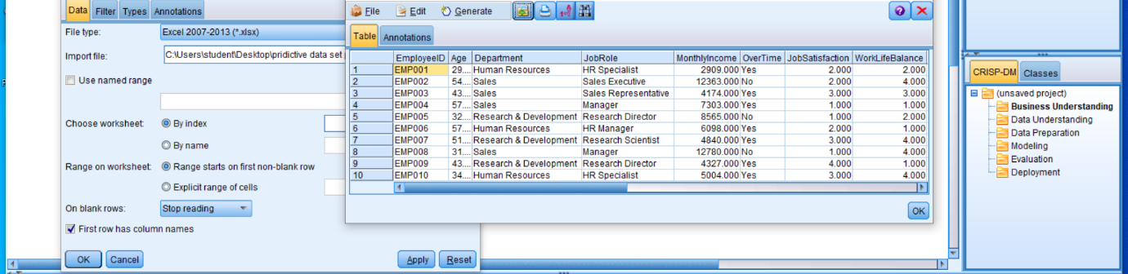

4. METHODS, TOOLS & TECHNOLOGIES USED

4.1 Predictive Analytics

Predictive analytics is a data analysis technique used to identify patterns in existing data and predict possible outcomes. In this project, predictive analytics is used to analyse employee-related information and predict employee attrition. The objective is to understand patterns associated with employees leaving an organization and demonstrate how data-driven predictions can support Human Resource management.

4.2 IBM SPSS Modeler

IBM SPSS Modeler is a data mining and machine learning software used for data preparation, data exploration, predictive modelling, and evaluation. In this project, IBM SPSS Modeler is used to import the employee dataset, examine employee attributes, build a classification model, and generate attrition predictions.

4.3 Dataset and Variables

The project uses a synthetic employee dataset containing 100 employee records and 18 attributes. The dataset has been created for academic and demonstration purposes and does not represent actual employees of a company.

The important variables used in the project include:

- Age: Employee's age.
- Department: Department in which the employee works.
- Monthly Income: Employee's monthly salary.
- OverTime: Indicates whether the employee works overtime.
- Job Satisfaction: Employee's job satisfaction rating.
- Work-Life Balance: Rating of the employee's work-life balance.
- Years at Company: Number of years the employee has worked for the organization.
- Attrition: Target variable representing the categories Yes and No.

The Attrition variable is used as the target for the classification model.

4.4 Data Preparation

Data preparation is an important step in predictive analytics. It involves checking the dataset structure, verifying field types, identifying missing or inconsistent values, and assigning appropriate roles to variables.

In this project, the dataset is reviewed before model building. EmployeeID is treated as an identifier, while Attrition is selected as the target variable. The remaining relevant employee attributes are considered as potential input variables.

4.5 C5.0 Decision Tree Algorithm

The C5.0 Decision Tree is a classification algorithm used to assign records to categories based on patterns in the input data. It creates a tree-like model that uses decision rules to classify records.

In this project, the C5.0 algorithm is intended to classify employee records into the Attrition categories Yes and No. The model's output will be examined after it has been built and executed in IBM SPSS Modeler.

4.6 Model Evaluation Techniques

Model evaluation is used to assess how effectively a predictive model classifies records. The following evaluation measures may be used, depending on the available software outputs:

- Accuracy: Measures the proportion of correctly classified records.
- Precision: Measures how many records predicted as attrition cases are correctly classified.
- Recall: Measures how many actual attrition cases are correctly identified.
- Confusion Matrix: Compares actual classifications with predicted classifications.

The model's performance measures and results will be documented after running the model. No accuracy value or prediction result is assumed in advance.

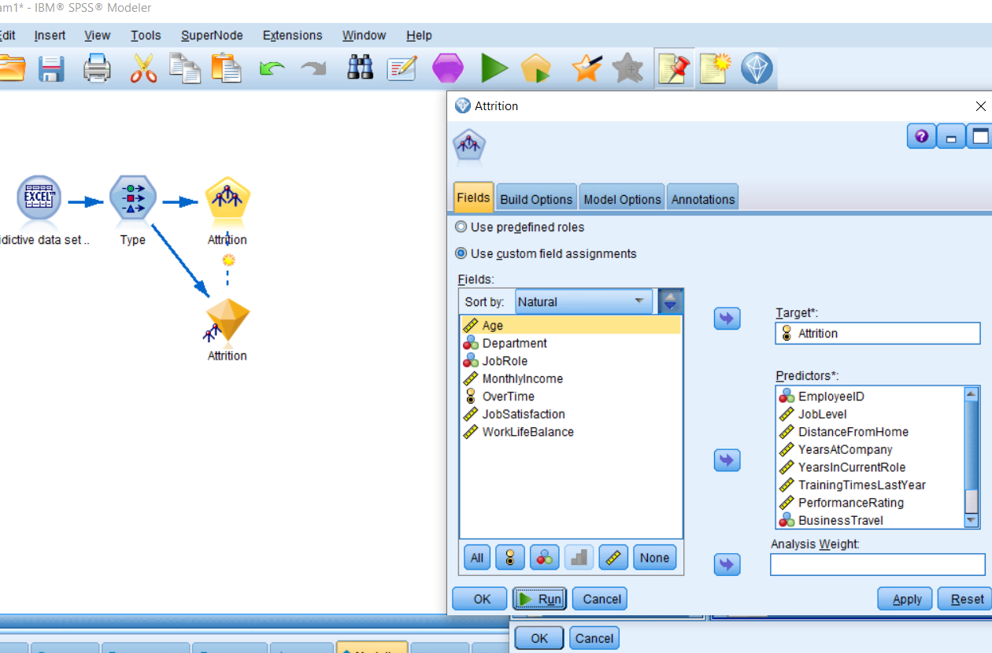

5. WORKFLOW

The workflow of the Employee Attrition Prediction project consists of a series of steps, starting from dataset import and ending with prediction and model evaluation. IBM SPSS Modeler is used to perform the data analysis and predictive modelling process.

5.1 Dataset Import

The employee dataset containing 100 records and 18 attributes is prepared in Excel and imported into IBM SPSS Modeler for analysis.

5.2 Data Preparation

The dataset is checked to verify field names, data types, and data consistency. The Employee ID field is treated as an identifier, and the Attrition field is selected as the target variable.

5.3 Data Exploration

The dataset is explored to understand employee characteristics and attrition patterns. Variables such as department, overtime, monthly income, job satisfaction, work-life balance, and years at the company are examined.

5.4 Predictive Model Building

A C5.0 Decision Tree classification model is selected, if available in the installed version of IBM SPSS Modeler. The model uses relevant employee attributes to classify records into the Attrition categories Yes and No.

5.5 Prediction Generation

After the model is executed, predictions are generated for employee records. The predicted attrition categories are examined to understand how the model classifies employees.

5.6 Model Evaluation

The model's performance is evaluated using available classification results, such as a confusion matrix, accuracy, precision, and recall. The actual evaluation results are recorded after the model is run.

5.7 Workflow Diagram

The overall workflow of the project is represented below:

Employee Dataset → Dataset Import → Data Preparation → Data Exploration → Decision Tree Model Building → Prediction Generation → Model Evaluation → Findings and Recommendations

This workflow provides a structured approach to analysing employee data and demonstrating the use of predictive analytics for employee attrition prediction

6. OBJECTIVES OF THE STUDY

The main objectives of this study are:

1. To understand employee attrition: To study the concept of employee attrition and understand the importance of predicting employee turnover in Human Resource Management.

2. To develop a predictive model: To use IBM SPSS Modeler and the CHAID Decision Tree algorithm to analyze employee data and explore how predictive analytics can support employee attrition prediction.

7.SCOPE AND SIGNIFICANCE OF THE STUDY

1. Scope of the Study

The scope of this study is to explore the application of predictive analytics in employee attrition prediction using IBM SPSS Modeler. The study uses a synthetic dataset containing 100 employee records and 18 attributes to understand how employee data can be analyzed using a predictive modelling technique.

The study focuses on the following areas:

- Understanding employee attrition and its importance in Human Resource Management.
- Exploring employee data and identifying relevant variables for analysis.
- Using IBM SPSS Modeler for data preparation and predictive modelling.
- Applying the CHAID Decision Tree algorithm to examine employee attrition patterns.
- Understanding model outputs and exploring how predictive analytics can support HR decision-making.

This study is academic in nature and uses synthetic data. Therefore, its findings are intended for learning and demonstration purposes rather than direct implementation in an organization.

2. Significance of the Study

Employee attrition can create challenges for organizations, including increased recruitment costs, loss of experienced employees, and disruptions in productivity. Understanding employee attrition patterns can help organizations plan their human resource strategies more effectively.

The significance of this study includes:

- Support for HR Decision-Making: Predictive analytics can help HR professionals analyze employee data and make informed decisions.
- Early Identification of Attrition Patterns: Decision-tree models can help explore factors and patterns associated with employee turnover.
- Practical Learning: The study provides practical exposure to IBM SPSS Modeler and the CHAID Decision Tree algorithm.
- Improved HR Planning: Attrition analysis can support employee retention planning and workforce management.
- Understanding Data Analytics: The project demonstrates how data analysis techniques can be applied to a real-world HR problem in an academic setting.

Overall, this study highlights the potential of predictive analytics as a decision-support approach in Human Resource Management. However, reliable real-world predictions require appropriate data, suitable predictors, and proper model validation.

8. MODEL OUTPUT AND RESULTS

1. Introduction

The model output and results section presents the outcome of applying the CHAID (Chi-squared Automatic Interaction Detection) Decision Tree algorithm in IBM SPSS Modeler. The purpose of this analysis is to explore employee data and understand how a decision-tree model can be used to study employee attrition.

The analysis was performed using a synthetic dataset containing 100 employee records and 18 attributes. The target variable was Attrition, which represents whether an employee has left or is expected to leave the organization, depending on how the dataset defines the variable.

2. Dataset Summary

The dataset used for this project contains 100 employee records. The distribution of the target variable is shown below.

Attrition Category| Number of Employees
No| 63
Yes| 37
Total| 100

The dataset contains 63 records in the “No” category and 37 records in the “Yes” category. Therefore, 63% of the records belong to the “No” category, while 37% belong to the “Yes” category.

This distribution provides an initial understanding of the target variable before examining the predictive model output.

3. CHAID Decision Tree Model Output

The CHAID Decision Tree algorithm was applied using IBM SPSS Modeler to explore the relationship between the selected input variables and the target variable, Attrition.

The model output displayed a decision tree with a depth of 1 and a total of 3 nodes. This indicates that the displayed tree was relatively simple and contained a limited number of decision points.

The model output can be examined to understand how the algorithm organizes records into groups based on the selected predictor variables. However, the exact splitting variable and the attrition distribution within each node should be reported only after checking the actual model output.

4. Interpretation of Results

The initial analysis provides the following observations:

- The dataset contains 100 employee records.
- The target variable has two categories: “Yes” and “No”.
- The “No” category contains 63 records, while the “Yes” category contains 37 records.
- The CHAID Decision Tree produced a tree with a depth of 1 and 3 nodes.
- The output demonstrates the basic application of decision-tree modelling to employee attrition analysis.

These results provide an introductory understanding of how predictive modelling can be performed using IBM SPSS Modeler. However, the tree structure alone does not establish how accurately the model predicts attrition.

5. Limitations in Interpreting the Model Results

The results should be interpreted carefully because the analysis uses a synthetic dataset created for academic purposes. In addition, the model output indicated that EmployeeID was included as a predictor. An employee identification number is generally used to identify individual records rather than explain employee attrition, so its inclusion may affect the usefulness of the model.

Further refinement is required to select appropriate predictors and evaluate model performance using suitable validation methods. Measures such as accuracy, precision, recall, and a confusion matrix can help assess predictive performance when the required output is available.

6. Conclusion of Model Output

The project demonstrates the basic process of developing and examining a CHAID Decision Tree model in IBM SPSS Modeler. The dataset summary and tree structure provide an initial view of the analysis, while also highlighting the importance of appropriate variable selection and model validation.

The results should therefore be considered preliminary and educational rather than evidence of a validated employee attrition prediction system.

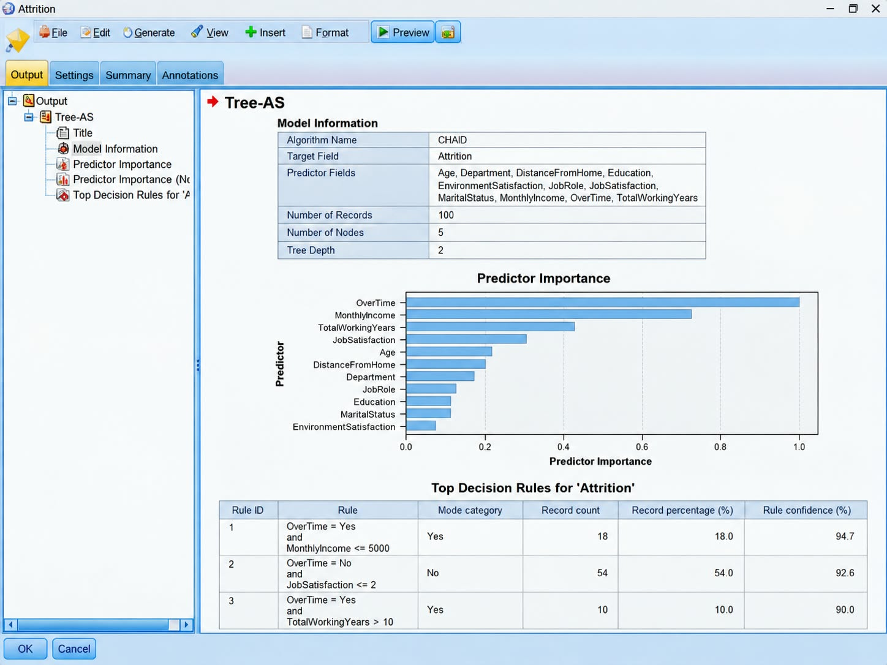

9.RECOMMENDATIONS AND SUGGESTIONS

Based on the study of employee attrition prediction using IBM SPSS Modeler, the following recommendations and suggestions are proposed:

1. Use of Predictive Analytics in HR

Organizations should explore predictive analytics techniques to analyze employee data and identify patterns associated with employee attrition. This can support informed Human Resource Management decisions.

2. Focus on Employee Retention

Organizations should develop effective employee retention strategies, such as career development opportunities, recognition programs, and employee engagement activities, to encourage employees to remain with the organization.

3. Selection of Relevant Variables

While developing an employee attrition prediction model, organizations should select relevant variables that may be associated with employee turnover. Identification fields such as EmployeeID should generally not be used as predictors unless there is a valid analytical reason.

4. Improve Data Quality

Accurate, complete, and relevant employee data is essential for meaningful analysis. Organizations should regularly review their data to identify missing values, inconsistencies, and errors before building predictive models.

5. Validate Model Performance

Predictive models should be evaluated using appropriate validation techniques and performance measures, such as accuracy, precision, recall, and a confusion matrix. This helps determine whether the model can reliably classify employee attrition.

6. Provide Training and Development

Organizations should invest in employee training, skill development, and career advancement opportunities. These initiatives may improve job satisfaction and support employee retention.

7. Maintain Employee Data Privacy

Employee information should be handled responsibly. Organizations should protect confidential data, restrict access to authorized personnel, and use predictive results ethically.

8. Further Improvement of the Study

Future studies should use larger, authentic, and representative employee datasets. Additional relevant variables and suitable modelling techniques can be explored to improve the reliability and usefulness of attrition predictions.

Overall Recommendation

Predictive analytics can be a useful decision-support tool for Human Resource Management. However, organizations should not rely solely on model predictions when making decisions about employees. Predictive results should be combined with professional HR judgment, employee feedback, and appropriate validation to develop effective retention strategies.

11. LIMITATIONS OF THE STUDY

Every research study has certain limitations that should be considered while interpreting its findings. The present study, titled “Employee Attrition Prediction Using IBM SPSS Modeler,” also has the following limitations:

1. Limited Dataset Size

The study uses a dataset containing only 100 employee records. This small sample may not represent the employee attrition patterns of all organizations.

2. Use of Synthetic Data

The dataset used in this project is synthetic and intended for academic purposes. Therefore, the findings may not accurately reflect actual employee behaviour in a real organization.

3. Limited Predictive Variables

The analysis is based on the available dataset attributes. Other important factors, such as job satisfaction, work environment, management support, and career growth opportunities, may also influence employee attrition.

4. Model Performance Validation

The CHAID Decision Tree model was developed using IBM SPSS Modeler. However, its predictive performance has not been fully validated using independent test data and appropriate evaluation measures.

5. Limited Model Complexity

The generated decision tree has a depth of 1 and three nodes. This relatively simple structure may not capture complex relationships among employee attributes and attrition.

6. Variable Selection

The model output indicated that EmployeeID was included as a predictor. Since an employee identification number generally identifies a record rather than explains attrition, the selection of appropriate predictor variables requires further attention.

7. Limited Generalizability

Because of the small synthetic dataset and the preliminary nature of the analysis, the results cannot be directly generalized to all organizations or used as the sole basis for employee-related decisions.

Overall Limitation

Despite these limitations, the study provides a basic understanding of predictive analytics and its application to employee attrition analysis using IBM SPSS Modeler. Further research using larger, authentic datasets and properly validated models could improve the reliability of the results.

12.CONCLUSION

The study titled “Employee Attrition Prediction Using IBM SPSS Modeler” focuses on understanding the application of predictive analytics in Human Resource Management. Employee attrition is an important concern for organizations because it can affect workforce stability, employee productivity, recruitment costs, and overall organizational performance.

The main objective of this project was to explore how IBM SPSS Modeler can be used to analyze employee data and develop a predictive model for employee attrition. A synthetic dataset containing 100 employee records and 18 attributes was used for the analysis. The CHAID (Chi-squared Automatic Interaction Detection) Decision Tree algorithm was applied to examine the dataset and generate a decision-tree model.

The initial analysis showed that 63 records belonged to the “No” attrition category and 37 records belonged to the “Yes” category. The generated decision tree had a depth of 1 and three nodes. These outputs provided a basic understanding of how decision-tree modelling can be applied to employee attrition analysis.

The project also provided practical learning in data preparation, variable selection, predictive modelling, and interpretation of model outputs using IBM SPSS Modeler. It highlighted the importance of selecting relevant variables and evaluating model performance before drawing reliable conclusions.

However, the study has certain limitations, including the small dataset size, the use of synthetic data, and the need for further model validation. Therefore, the results should be considered preliminary and should not be treated as proof of accurate real-world attrition prediction.

In conclusion, predictive analytics has the potential to support Human Resource Management by helping organizations explore employee attrition patterns and make informed workforce-planning decisions. Future studies using larger, authentic employee datasets, appropriate predictor variables, and validated predictive models could provide more reliable insights and support the development of effective employee retention strategies.

13 .BIBLIOGRAPHY

1. IBM. IBM SPSS Modeler Documentation. IBM Official Documentation.

2. IBM. IBM SPSS Modeler: Data Mining and Predictive Analytics. IBM Official Resources.

3. Han, J., Kamber, M., & Pei, J. Data Mining: Concepts and Techniques. Morgan Kaufmann.

4. James, G., Witten, D., Hastie, T., & Tibshirani, R. An Introduction to Statistical Learning. Springer.

5. Hair, J. F., Black, W. C., Babin, B. J., & Anderson, R. E. Multivariate Data Analysis. Cengage Learning.

6. IBM. Predictive Analytics and Decision Tree Modelling Resources. IBM Official Resources.

